Basic web app

Privacy is having attribute authorize

Run will give error

To Use this, you need to add a middle where use authentication and use authorization and it will ask for default challenge scheme

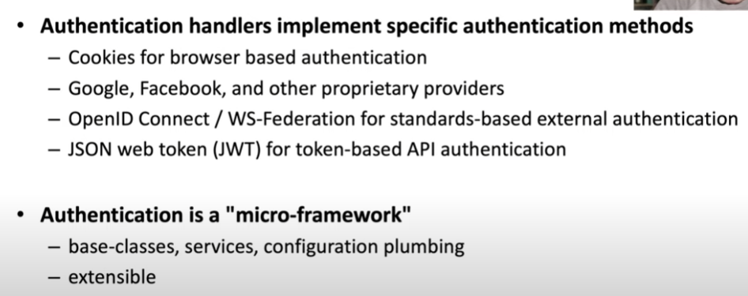

Different handler is composed together and place in the DI container.

Each handle must have a unique name. Microsoft call it authentication Scheme

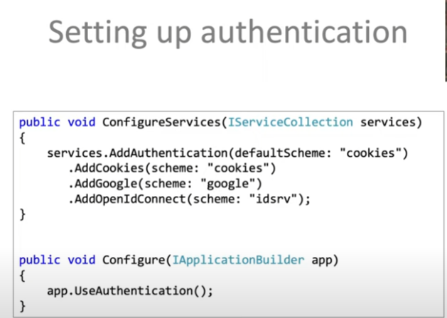

Build => Claims=> claim identity=> claim Principle

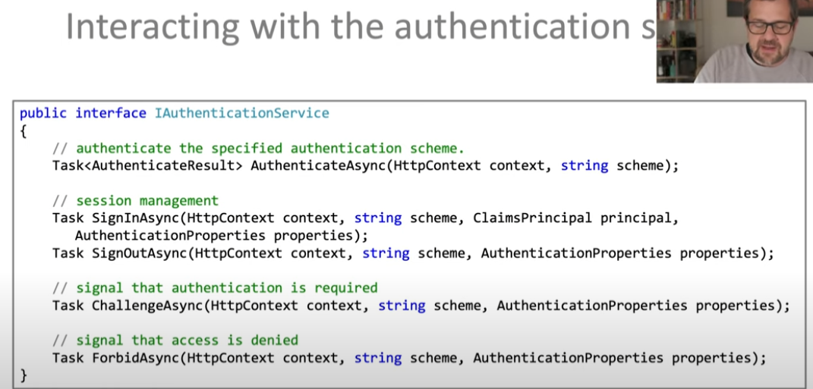

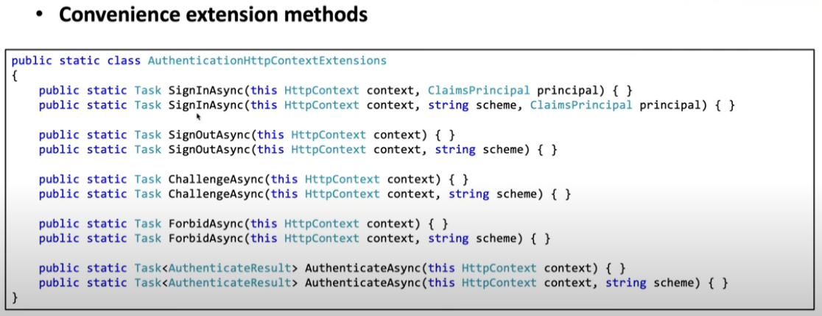

First thing is sign in and sign out with or without scheme

Sign in , it will create response header and make a round trip the browser and in the next trip it will send the response cookie.

Use authentication will check the useAuthenticate and call Authenticate async

You will now see a cookie

When use it anonymous use it will called the challenge

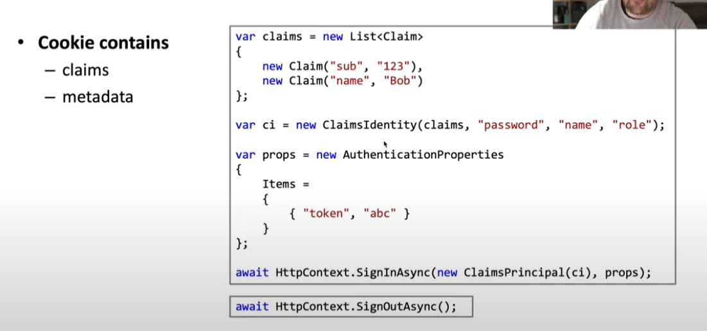

Authentication property to add additional items

How data is protected.

Data is serialised and protected

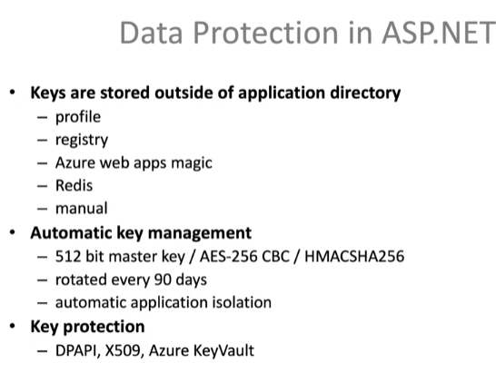

You can see that under local asp.net Data protection keys

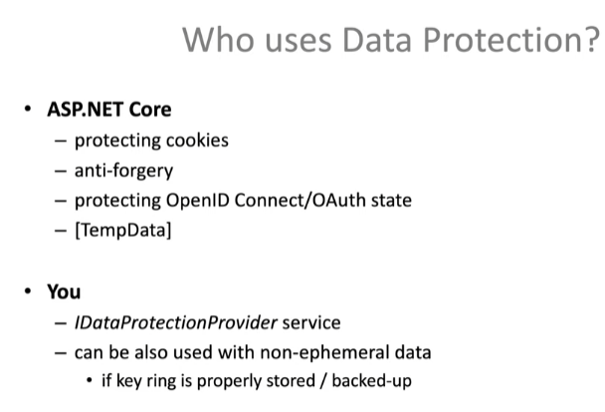

**Authorization**

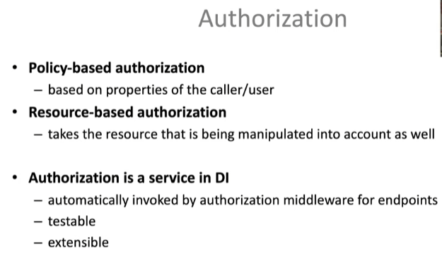

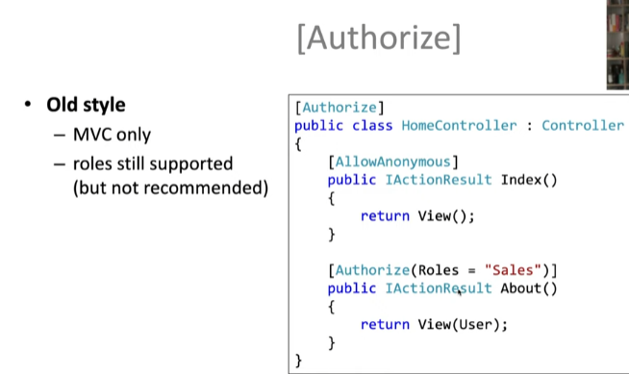

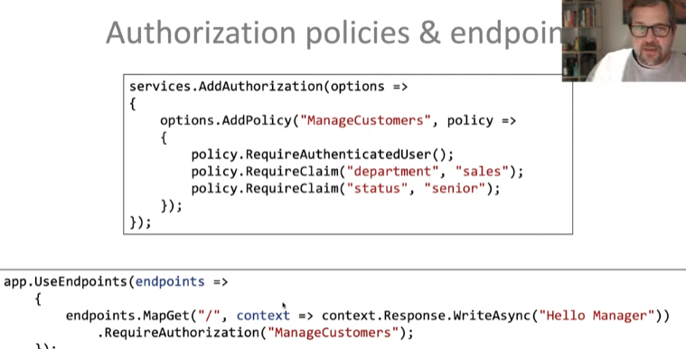

Create New page and add policy (customer)

As the new policy cannot allow Privacy2 page -> but as used is authenticated **forbidAsync** will be called

Challenge means with login you can fix but will forbid u can’t

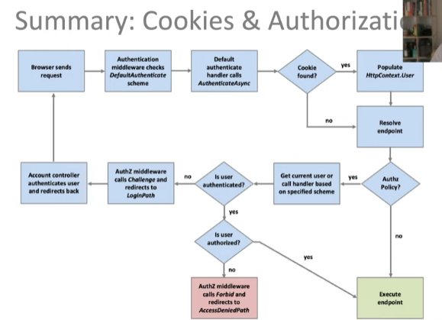

External Authentication

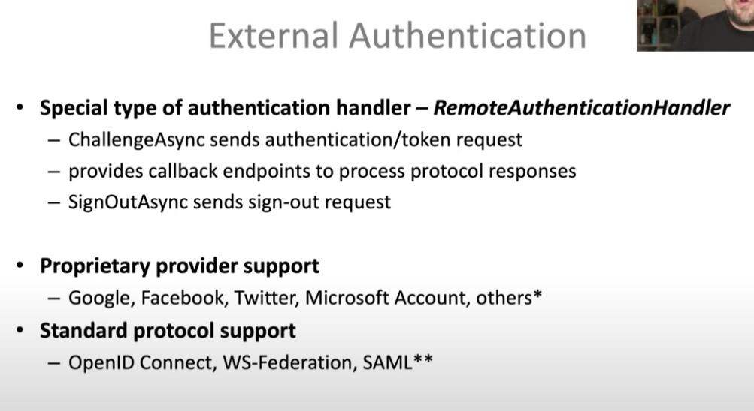

External handle -> install package , set up properties and finally add the handlers

For example -> external handler will find the identity and then will let you know what to do with that identity and then finally hand over to other handle let say default handler

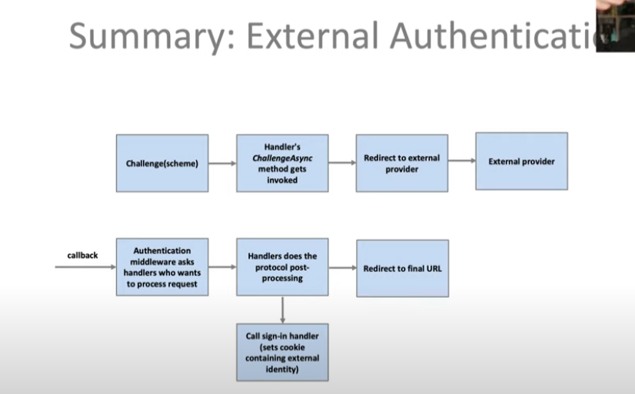

Now Callback patterns

When call back we consider user as anonymous

Get identity from external , store in temp cookies. Map it to user cookie and finally sign in

